Data Port Quick Find for ECERF Building

USER’S MANUAL

USER'S MANUAL

TABLE OF CONTENTS

Page #
Contents
1. GENERAL INFORMATION 1
1.1 System Overview 1
1.2 Authorized Use Permission 1
2. Environment Requirement for the App 2
2.1 Install Python 2.7.11 and Python 3.5.1 2
2.1.1 Install Python 2.7.11 2
2.1.2 Install python 3.5.1 2
2.1.3 Install Virtual Environments 4
2.1.4 Install Django 6
3. Presentation of the app 7
3.1 Run the App 7
3.2 Search by Data Port Number 7
3.3 Search by Room Number 9
3.4 Add Path Nodes 10

GENERAL INFORMATION

1.1 System Overview
This simple local web app that can run on localhost:9088 is built using python 2.7, Django and Sqlite3. Its main function is finding a specified Data Port in ECERF building and drawing the shortest path from the floor’s main entrance to the destination (the data port). You also can get a data post list for a specified room. The Add Path Nodes function is used to create path nodes in case some renovation will block the hallway in the future.

1.2 Authorized Use Permission
Usage of this software is limited to every authorized staff.
The admin account is admin and its password is ecerfadmin.

Environment Requirement for the App

2.1 Install Python 2.7.11 and Python 3.5.1
Download both version pythons firstly. Here, you will learn how to run the app in virtual environments.

Install Python 2.7.11
Follow the installation guide to install Python 2.7.11. Recommend to install it under the C root directory.
Note: Check “Add python.exe to Path” option.
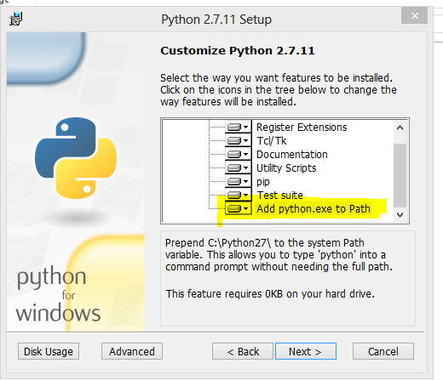
Install Python 2.7.11

Install python 3.5.1
Follow the customize installation guide to install Python 3.5.1. Recommend to install it under the same root directory with Python 2.7.11.
Note: Uncheck “Add python.exe to Path” option. (Install Python 3.5.1 A)
Uncheck “Add Python to environment variables” (Install Python 3.5.1 B)
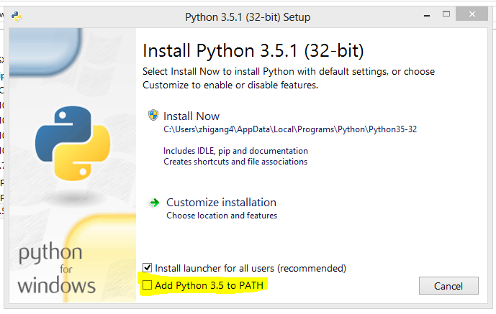
Install Python 3.5.1 A
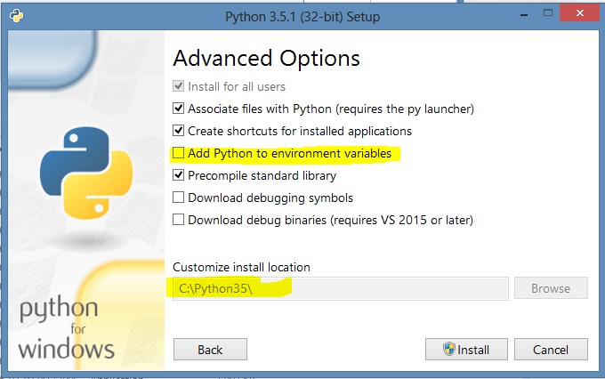
Install Python 3.5.1 B

Install Virtual Environments
Right now, the default Python environment is Python2.7.11. Open Command Prompt and enter the command python –version

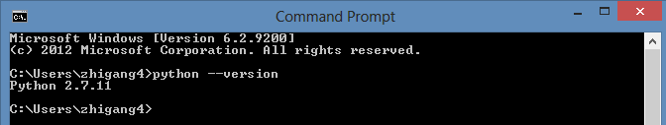
The default python’s version
A Virtual Environment is a tool to keep the dependencies required by different projects in separate places, by creating virtual Python environments for them.
- virtualenv is a tool to create isolated Python environments. virtualenv creates a folder which contains all the necessary executables to use the packages that a Python project would need.
Install virtualenv via pip: pip install virtualenv
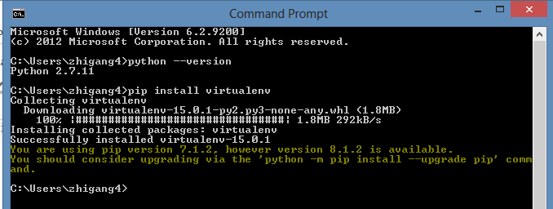
Install virtualenv

- virtualenvwrapper provides a set of commands which makes working with virtual environments much more pleasant. It also places all your virtual environments in one place.
For Linux, to install (make sure virtualenv is already installed):
$ pip install virtualenvwrapper
For Windows, to install (make sure virtualenv is already installed):
$ pip install virtualenvwrapper-win
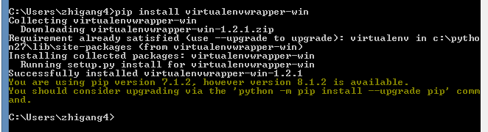
Install virtualenvwrapper-win
- create virtual environments python27 and python35
$ mkvirtualenv python27
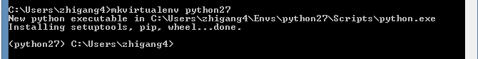
$ mkvirtualenv --python=c:\python35\python.exe python35
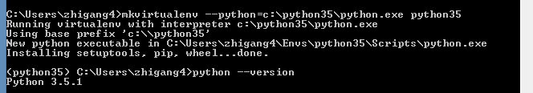
FYI:
When you create python35 virtual environment, if you get VCRUNTIME140.dll missing error. Download Visual C++ Redistributable for Visual Studio 2015 and install it. Recommend to download both x64 and x86 version packages and install them.
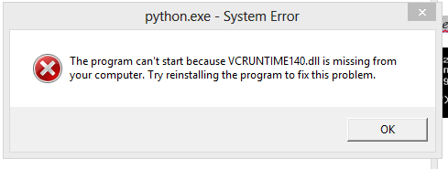
VCRUNTIME140.dll missing error
Basic usage:
workon: List or change working virtual environments
deactivate: Switch from a virtual environment to the system-installed version of Python.
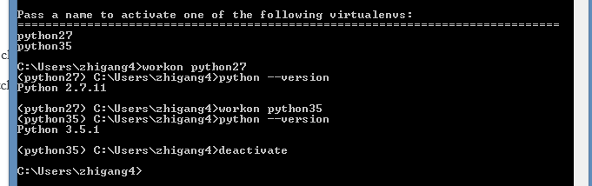
Basic Usage

Install Django
Use pip to install Django for each virtual environments and default system-installed version of Python if you like. The Part3 demo is running under the default version of Python.
pip install Django==1.9.6
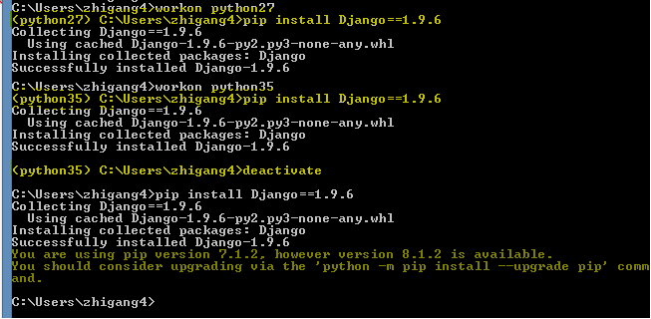
Install Django

presentation of the app

3.1 Run the App
For Windows users, please run Command Prompt first and then change directory to app folder. The demo is running under the default version of Python.
Last input the command python manage.py runserver 9088 .

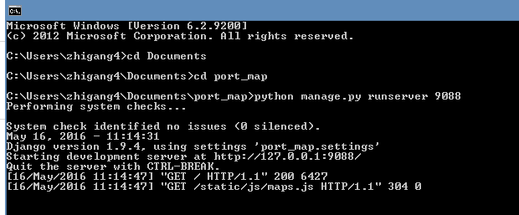
Command to run the app

3.2 Search by Data Port Number
The default floor number is 3. Or you can select desired level from left side level bar.
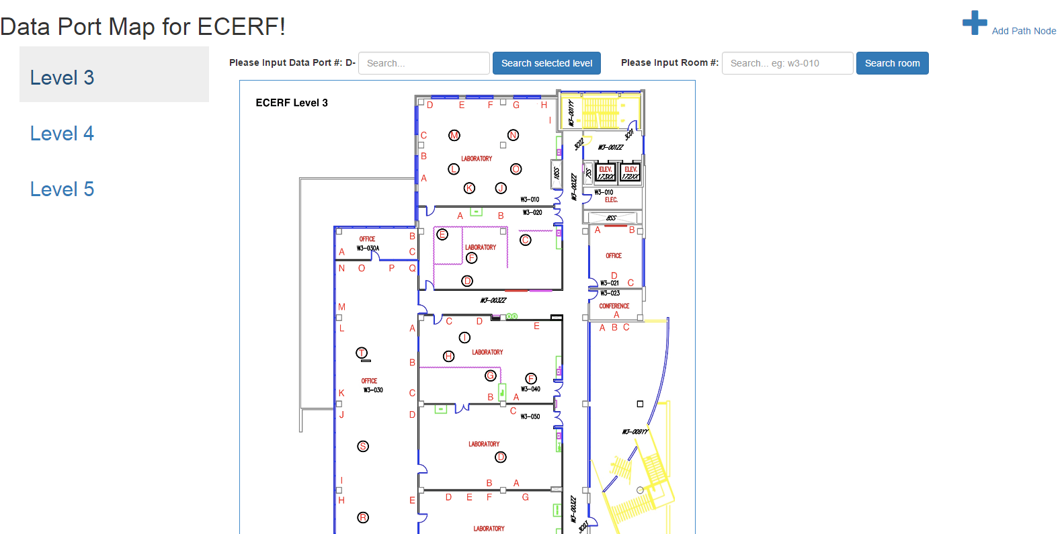
Searching interface

If the desired data port is exist, its detail will be displayed, a blinking circle will be printed overplay on the floor map. Meanwhile if the data port’s location is known, the shortest path from the floor’s main entrance to the destination will be drew.

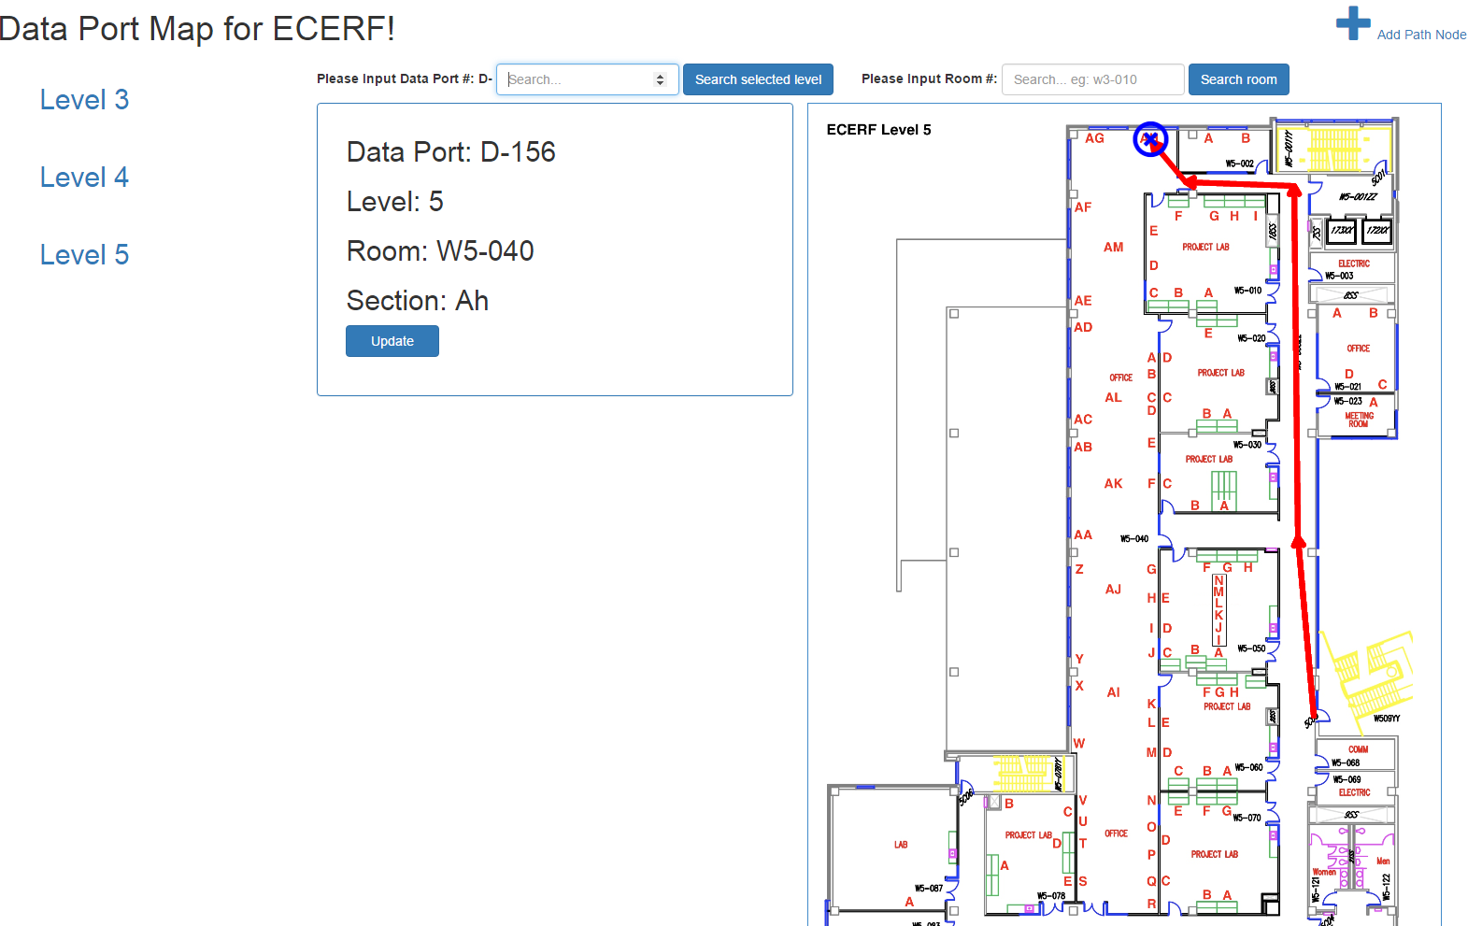
Search Result

If you think that the coordinate of the data port is wrong, you can update it by clicking  button. And then click the new coordinate on the map.
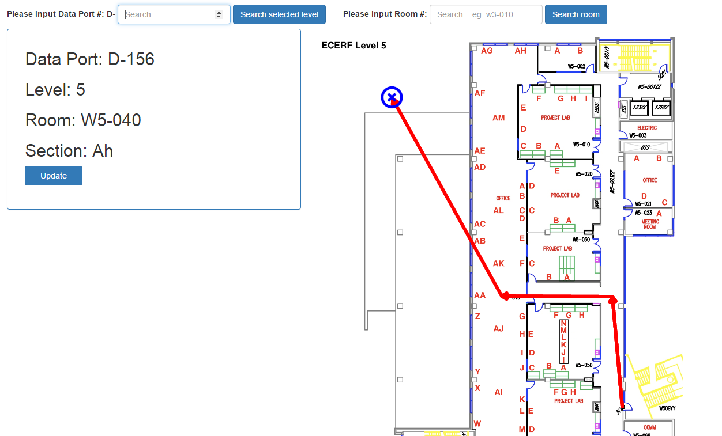
Update Coordinate

3.3 Search by Room Number
Inputting the Rom number, a relevant data port list will be displayed. Otherwise an error message will be display.
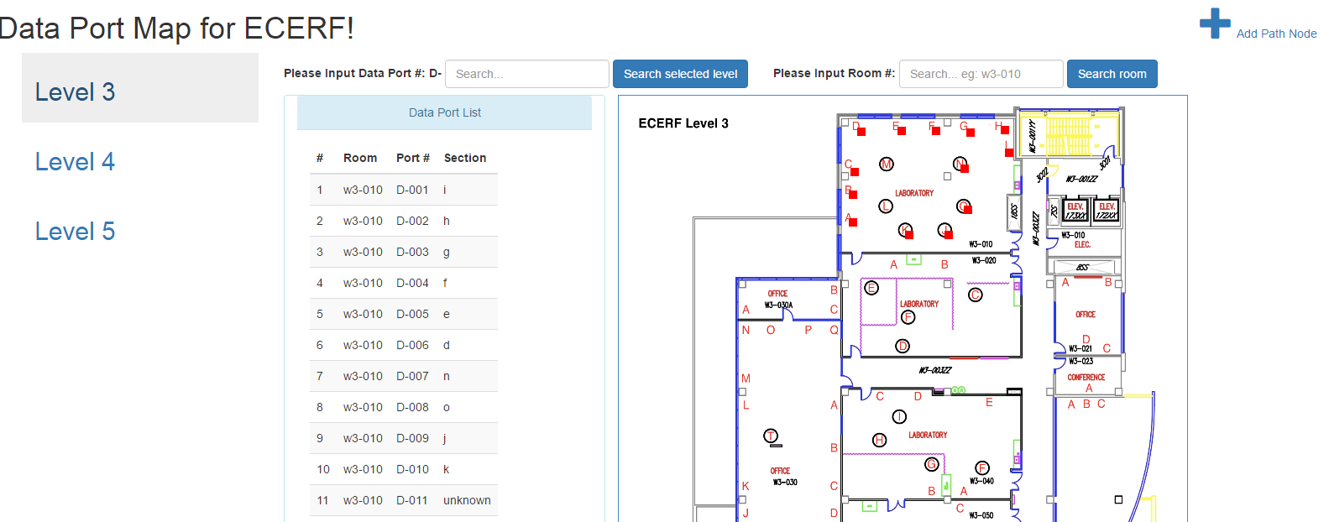
Search Result

3.4 Add Path Nodes
This function will be used only when a renovation blocks the hallway in the future and you need to create a node to draw the shortest path. The relation (edge) among the nodes will be maintained in Admin page.
Selecting a level, entering a node name, clicking on the map to get coordinate and clicking AddNote are all you need to do to add a path node.

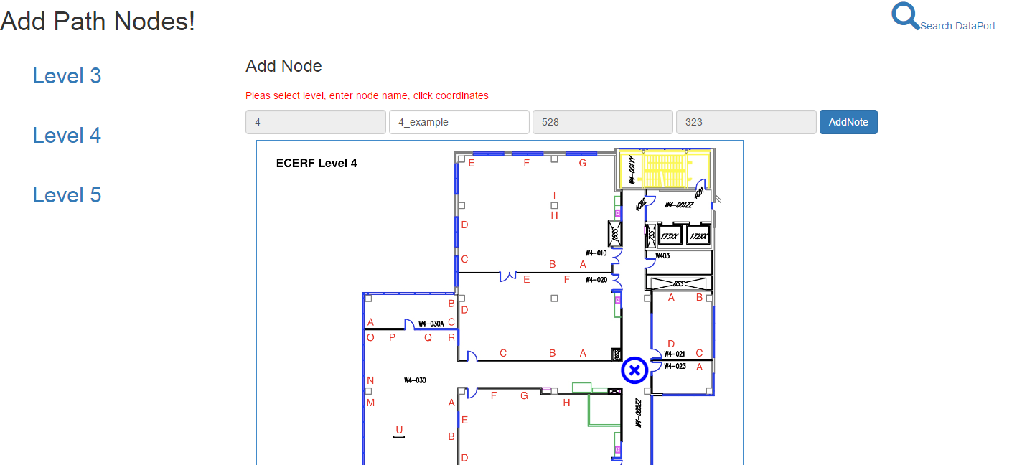
Add Path Nodes

